The Emotional World of Teens
Fostering your teen’s social emotional intelligence
Dr. Elizabeth Fedrick, PhD, LPC
Michael Klinkner, MSW, LCSW
www.evolvecounselingaz.com
Instagram: evolvecounselingaz / michael_klinknercounseling
YouTube / Podcast: Evolve Counseling and Behavioral Health Services

What is emotional intelligence?
- The ability to be aware of and effectively regulate one’s own emotions, as well as the ability to be aware of and show empathy towards others’ emotional states.
- “Emotional intelligence is generally said to include at least three skills: emotional awareness, or the ability to identify and name one’s own emotions; the ability to harness those emotions and apply them to tasks like thinking and problem solving; and the ability to manage emotions, which includes both regulating one’s own emotions when necessary and helping others to do the same” (Psychology Today).
How does emotional intelligence develop?
Emotional development is actually built into the architecture of teen’s brain in response to their individual personal experiences and the influences of the environments in which they live. Indeed, emotion is a biologically based aspect of human functioning that is “wired” into multiple regions of the central nervous system” (National Scientific Council on the Developing Teen, 2011). It happens through:
  - Genetics
  - Environment/Life experiences
  - Parenting style
Emotional development starts in infancy with interactions with caregivers
- How the parent responds to a child’s need and call for help.
- Children at this age are incapable of regulating emotions, and thus the parental response to the child’s emotions and needs will lay the groundwork for learning who/what is safe and how to respond in times of distress.
- The development of the “adaptive child” begins at this time when a child determines what behaviors are necessary to stay safe and get their needs met (being loud/disruptive, misbehaving in order to receive any type of attention people pleasing, meeting parents needs first, etc.).
- The parent-child relationship is the child’s first exposure to relational dynamics and is the foundation for what the child will expect out of future relationships
- These early life experiences lead to core beliefs of self, others, and the world as a whole
- Core beliefs are what set the stage for thoughts, feelings, and behaviors in future situations
The role the brain plays in emotional functioning & regulation
- Parts of the brain responsible for emotional processing & regulation:
-Amygdala
“Conversely, when a parent expresses defensive behaviors or heightened negative affect, the rodent work has shown that such cues are quite effective in amplifying amygdala reactivity” (National Scientific Council on the Developing Teen, 2011).
“Stimuli related to a (regulated) parent can modulate a physiological response to threat, namely that parental cues can dampen elevations in the stress hormone cortisol (in humans)” (National Scientific Council on the Developing Teen, 2011).
-Prefrontal cortex
- “This complex neurobiological interstate takes years to reach maturity. It is often the case that slow developing systems are highly susceptible to environmental pressures; that is, they exhibit a high degree of plasticity” (Tottenham, 2017)

The amygdala
- Contributes to emotional processing
- Susceptible to stressful events
- Leads to fight, flight, freeze response
- Releases neurotransmitters needed to handle a threat (perceived or otherwise)
- Designed to store emotional memories to protect us from similar threats in the future
- Not always accurate when sensing threats
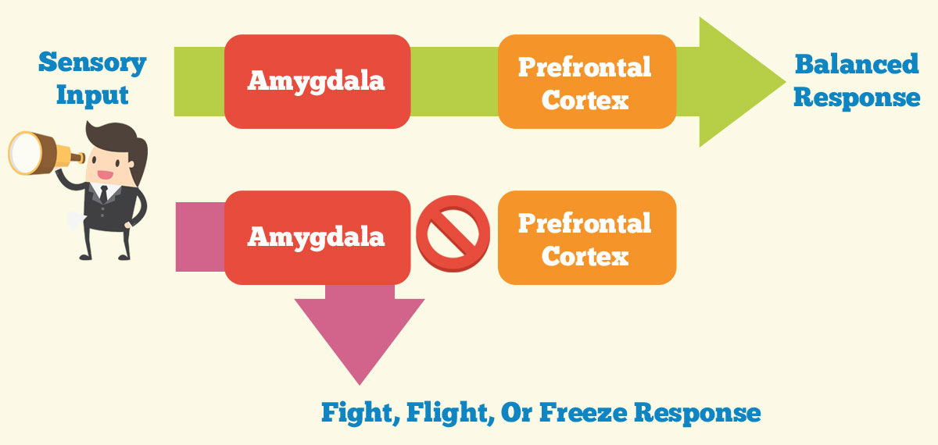

Prefrontal cortex
- Does not finish developing until mid-20s
- Limbic system (emotion center of the brain) develops at a much quicker rate
- Due to the slow rate of development, the prefrontal cortex is more susceptible to neuroplasticity and change
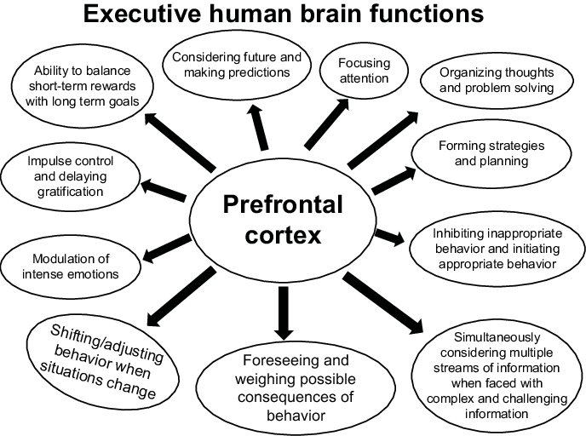
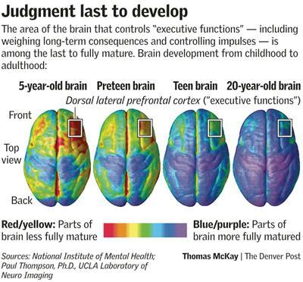

The impact of parenting styles
- Permissive
- Uninvolved
- Authoritarian
- Authoritative

What can we do to support optimal social/emotional development?
Parenting Evolved
Validate
- Be the calmest version of yourself you can be
- Let the child know their feelings are valid
- Label the emotion if they can’t
- Use calming skills, if need to
- Use statements like: ”that sounds like a lot.” “That would be hard.”
- Be careful to not give them the idea that they just “need to get used it” or “just get over it.”
Investigate
- Ask the right questions and wait for the answers
- Help your child focus on how they see the situation and when it got started
- Some examples are: “what started the emotion?” “When did you first start to get upset?”
- “What was the worst part for you?” “Does this kind of thing happen a lot?”
- “Is there any other way of looking at that situation, maybe from someone else’s point of view?”
Regulate
- Help them feel in control
- Help them explore their options: “what part can you solve?” “What do you think are the best options?” “Which option makes you feel the best?” “What part of this do you think you can change?” “What step are you ready to take right now?”
- Collaborate-get and use their inputs and opinions to solve the issue
- Break the problem down into smaller parts if needed
- Provide reassurance and cheerleading

Co-regulation
- Research says that when a teen sees and experiences a calm caregiver, they can also start to effectively regulate.
- Losing our tempers does not teach a child how to regulate theirs.
- Yelling, shaming, and chaos increases amygdala activity and decreases a child’s ability to effectively regulate.
- Consider time-ins when appropriate.
- Remember, we are products of our environment. So, what a teen sees, experiences, and learns is acceptable, will dictate future behaviors.

Intentional activities
- Date your teen
- Schedule regularly
- Get their input on activity/restaurant/etc.
- Prepare conversation starters
- Ask open-ended questions
- Ask about emotions/experiences
- Share about your emotions/experiences

Positive labeled praise
- Catch your teen doing good
- Praise 3x more than you redirect
- Label the specific positive behaviors that you are trying to increase
- Try to “let things go” when appropriate
- Use reward-based systems

One-on-one time
- Spending quality time with your teen leads to improved relationships, shows them that they are important to you and lets the teen feel safe with you (valuable when difficult situations arise in the future)
- Your teen picks the activity
- This is not the time to ask questions or teach life lessons
- Show interest (put your phone down)
- Running errands does not count as a primary source of one-on-one time
Avoid power struggles
- Figure out what is triggering you in that moment. What is it about your teen’s behavior is making you upset?
- A power struggle is sending the message that you are equals (diminishes authority)
- Give your teen choices and allow freedom when appropriate (is the request because it is convenient/your personal opinion vs. a safety or well-being expectation)
- Know when to walk away (pick your battles)
- Consistency is key (people will do what they know they can get away with)

Acknowledge and apologize for mistakes
- The willingness to apologize to your teen and take ownership of your mistakes will go a long way and teaches your teen how to do the same.
- Parents are human too
- Acknowledge mistakes (people do not “deserve” to be yelled at)
- Apologize (I made a mistake when I lost my temper with you, I am sorry)
- Do better next time
- It is not about the rupture, it is about the repair

Be Present
- The most important thing you can do to foster your teen’s social/emotional intelligence is to be present and aware
- Be aware of teen’s love language (Five Love Languages Quiz)
- Make time to ask open-ended questions
- Be consistent (so your teen knows what to expect)
- Focus on what your teen is doing RIGHT

Any questions, or if you would like more information about Evolve Counseling & Behavioral Health Services, please contact us at: efedrick@evolvecounselingaz.com
mklinkner@evolvecounselingaz.com

